Problems & Solutions Adobe MUSE

- Tabbed panels not pushing down content below !
Uncheck the box (Edit Together) in tabbed panel option
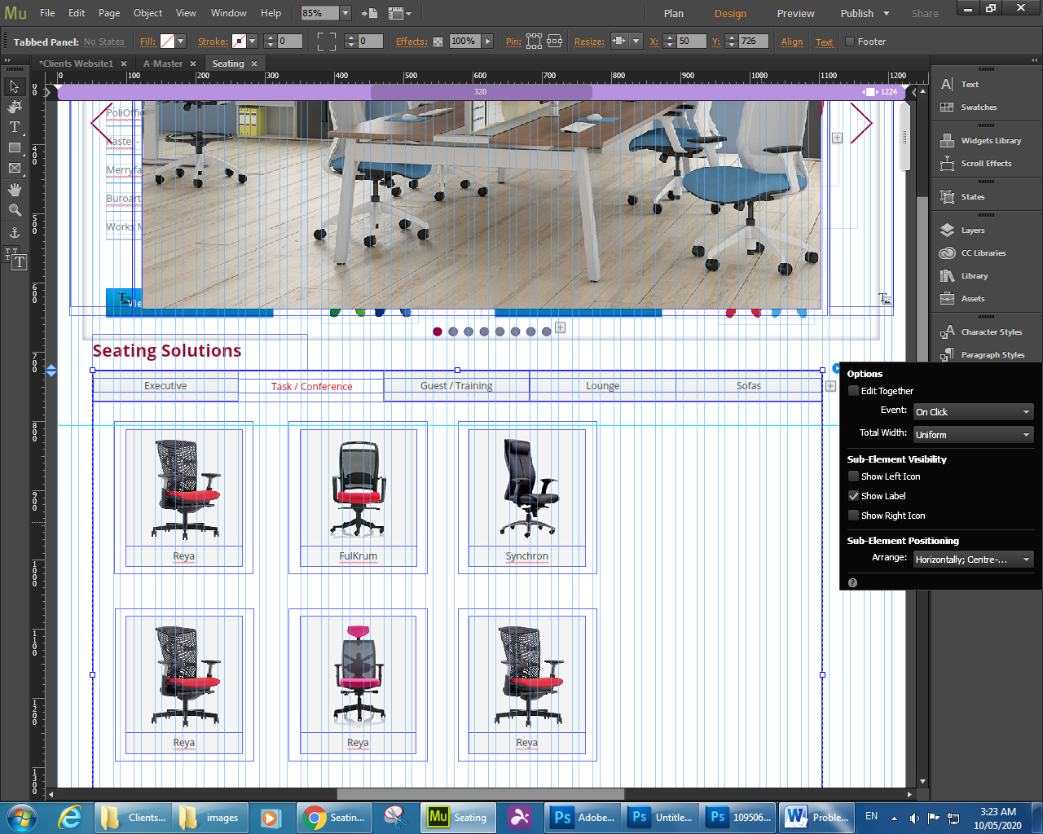

The above solution was wrong, the correct is:
In design mode, keep the tallest content in the tabbed panel is the active one
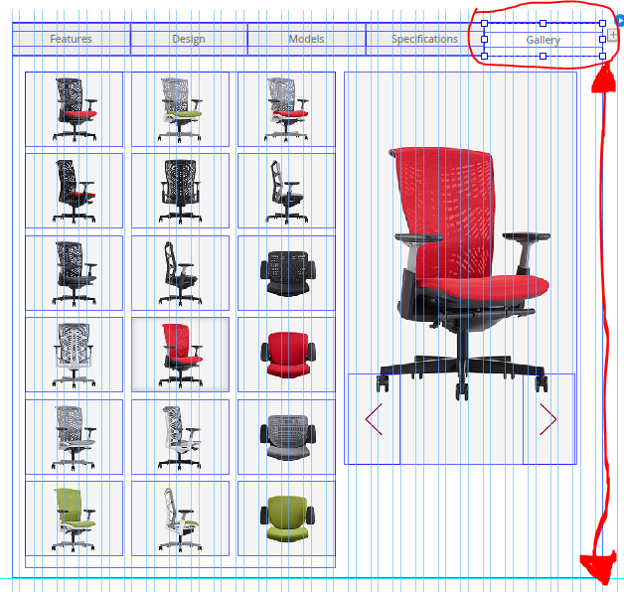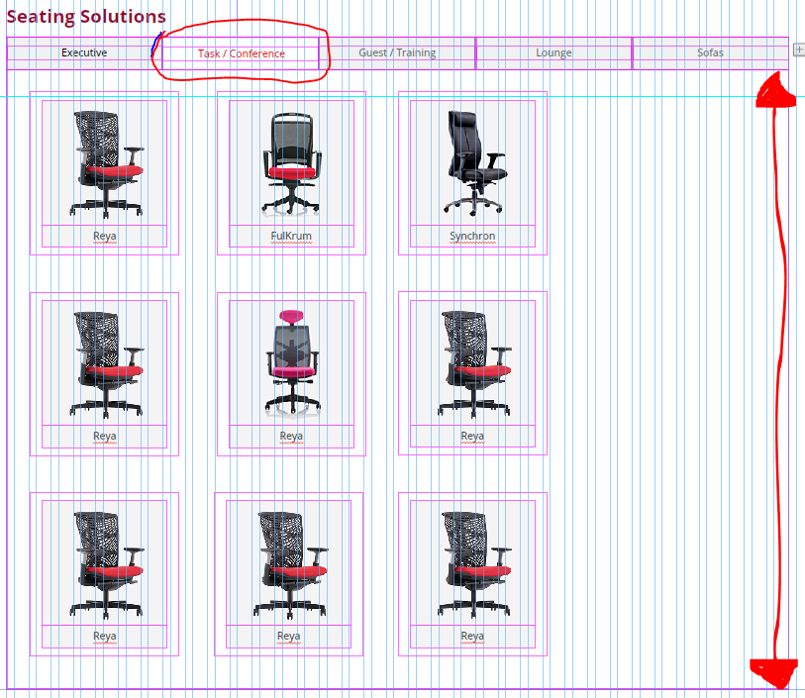

- To crop the image use : https://resizing.app/blog/how-to-resize-image-without-losing-quality/

- To Optimize image use : https://tinypng.com/

